Please return your completed membership form with $20 membership fee per child postmarked by April 24, 2025 to:
Iowa Swine Jackpot Series - Attn: Katlyn Cain, 58833 Hwy 210, Cambridge, IA 50046
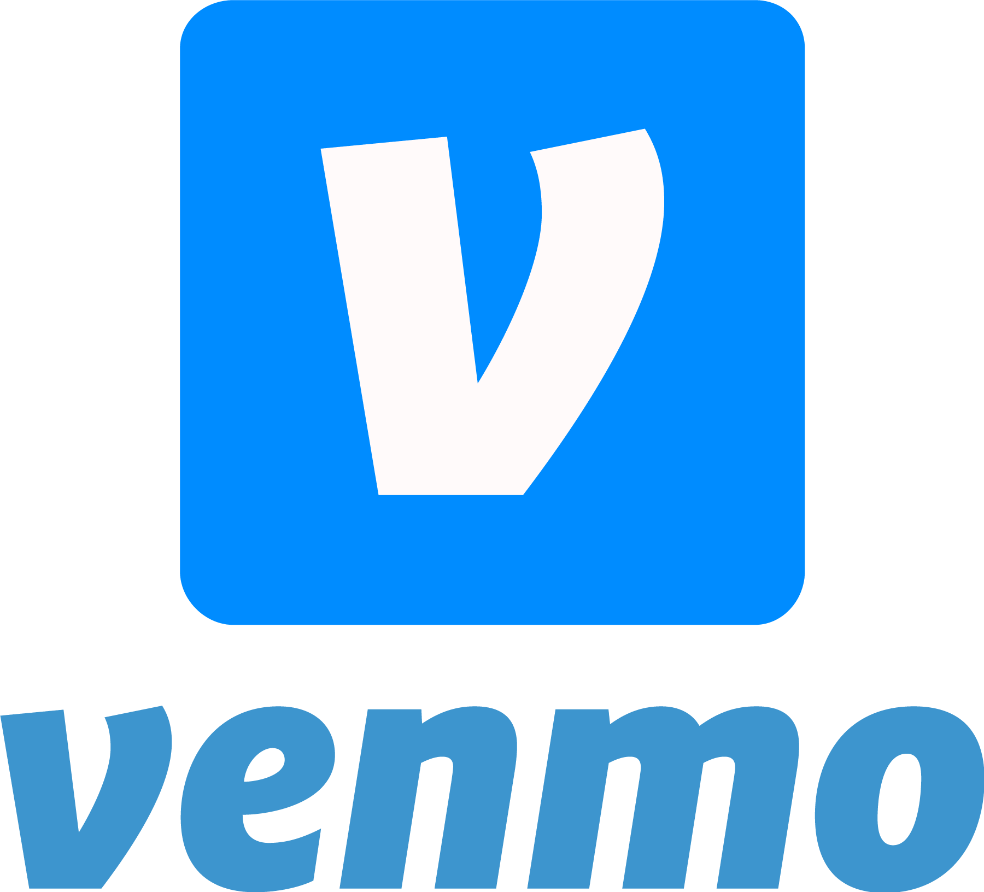
@IowaSwineJackpotSeries
The ISJS is an exciting way to learn more about showing livestock, get involved in the best livestock shows in Iowa, and win prizes based on your show performance this season! If you are interested in being a part of this association, and receiving information about upcoming events and shows, please complete this membership form (along with a parent/guardian signature, if you are under 18 years of age).

Child’s Name(s) | T-shirt size (youth or adult) | Birthdate | Age as of Jan 1, 2026

Do you plan to attend Grand Finale? Yes No
Parent Name(s)____________________________________________________________________________
Address __________________________________________ City________________________________
State _____________ Zip _____________________________ Phone (______) _____________________
E-mail Address (required) ________________________________________________________________
Additional E-mail Address (optional)________________________________________________________
T-shirt size (youth/adult sizes)
**Memberships received after April 24, 2026 will not be guaranteed an ISJS member tshirt**
**T-shirts will not be shipped to exhibitors**

If applicant is under 18 years of age, parents/guardian MUST complete this section.
I am the parent or guardian of the above referenced minor and I hereby consent to his/her participation in the ISJS. I understand and agree that information regarding club activities may be sent via email at the above email address. I reserve the right to remove the above referenced minor from the ISJS database, including the email address listed, at any time by contacting ISJS at the mailing address listed above. I agree to allow ISJS to use my child’s picture for promotional materials. By signing this form you are also agreeing to all portions of the most current posted Guidelines with specific attention to the Eligibility and Code of Conduct.
Parent/Guardian Print _____________________________________________
Signature ______________________________ Date_______________
Please be sure to follow us on Facebook and Instagram – Iowa Swine Jackpot Series
This is the quickest and most efficient way to update our membership. We will not be providing updates via email.
All show registration can be found on the website: Showman.app

